The Nelson Institute presents a talk by Brad Cadwallader: Great Trees of New Zealand — From Nelson to the Nation. Exploring the New Zealand Tree Register. 2PM, Sunday, October 4, at Nelson Public Library. Cost: $5.

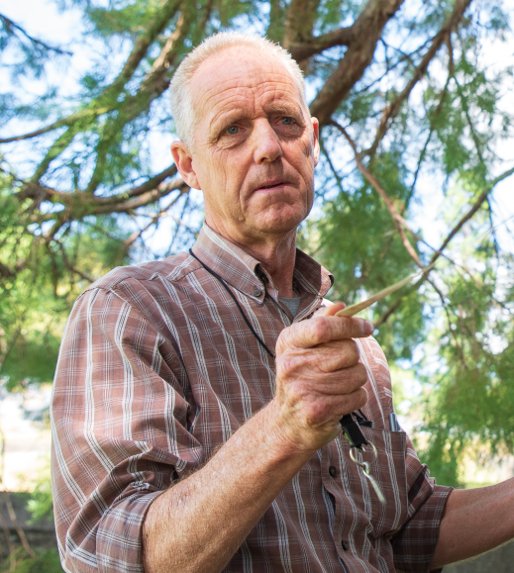
New Zealand has an exceptional tree heritage, from ancient native giants to an enviable collection of exotic trees. This presentation explores how our remarkable trees have been recorded over the past 150 years, culminating in the establishment of the NZ Notable Trees Trust and the launch of the New Zealand Tree Register in 2009.
Brad will take a practical look at the Register and how anyone can use it to discover, research and record significant trees. He’ll demonstrate how trees are submitted and measured, how records can be searched and mapped, and how photographs and historical information help tell the stories behind them.
Along the way we’ll meet some of New Zealand’s champion trees, including specimens of international significance, and take a closer look at some notable trees closer to home — from the Greenwood and Seymour oaks, Bishopdale kahikatea to the impressive London plane avenue at Tōtaranui. More than simply a database of big trees, the Register is a growing record of NZ’s living tree heritage and the stories that connect people, places and trees.
Brad has been working with trees since 1978, when he began practising arboriculture in Auckland. After studying Amenity Horticulture at Massey University and gaining further arboricultural experience in Canada, he returned to New Zealand and settled in Nelson in 1991, where he established a tree contracting business before moving into independent tree consultancy.
Brad is a past President of the New Zealand Arboricultural Association, a former Board member of the International Society of Arboriculture, and a Foundation Trustee of the NZ Notable Trees Trust. He has managed the Trust’s National Tree Register since its launch in 2009.
These days Brad’s professional life centres on mature and heritage trees, while his spare time is often spent reading about them, talking about them, or heading off to find and measure another one. He has a particular weakness for trees that are older than he is.

Preview Brad’s talk by listening to this interview: South Island stories: The trees we love and vote for | RNZ

